|  |
| --- |
| Circle Language Spec: Inheritance |

## System Command Extension

Another way to specialize a derived object is to let it define extra functionality around a *system* command. The previous section was actually a demonstration of how to extend the implementation of the Execute system command. But *other* system commands can be extended as well, such as the Value Set command. Here is an example where the Value Set command is post-extended by implementing the Value Changed event.

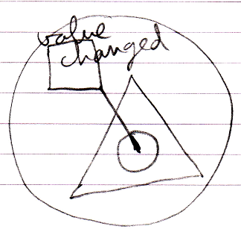

So then the derived class defines something that will be run every time the object’s value changes.